A
Lab Records of
Modern Operating System Design, Master's of Computer Application -I Sem


RUNGTA INTERNATIONAL SKILLS UNIVERSITY
SESSION: 2025-26

Submitted By: -
Mr. Lakshman Sahu Samiksha Singh
(Assistant Professor) REF/2025/03908

Submitted To:

RUNGTA INTERNATIONAL SKILLS UNIVERSITY, CG
SCHOOL OF INFORMATION TECHNOLOGY

Index
Sno | Name of Practical | Submission Date | Remarks
1. | Write a Python program to display Operating System name, version, and architecture using the platform library.
2. | Write a Python program to show Disk Partitions and Usage.
3. | Write a Python program to display total memory, used memory, and available memory using the psutil library.
4. | Write a Python program to list the top 5 running processes (process name + PID).
5. | Write a Python program to display Monitor Network Statistics (Bytes Sent/Received).
6. | Implement First Come First Serve (FCFS) CPU scheduling in Python.
7. | Implement Round Robin Scheduling with different time quantum.
8. | Implement Priority Scheduling and show waiting time vs turnaround time.

Experiment – 1

Aim: Write a Python program to display Operating System name, version, and architecture using the platform library.
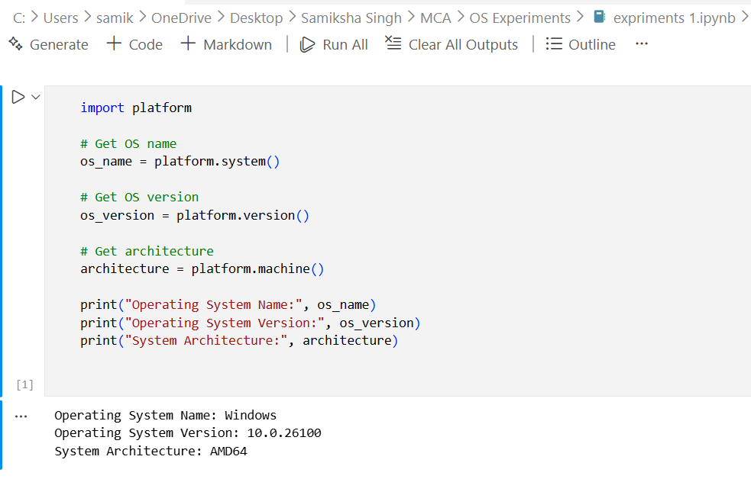
Experiment – 2
Aim: Write a Python program to show Disk Partitions and Usage

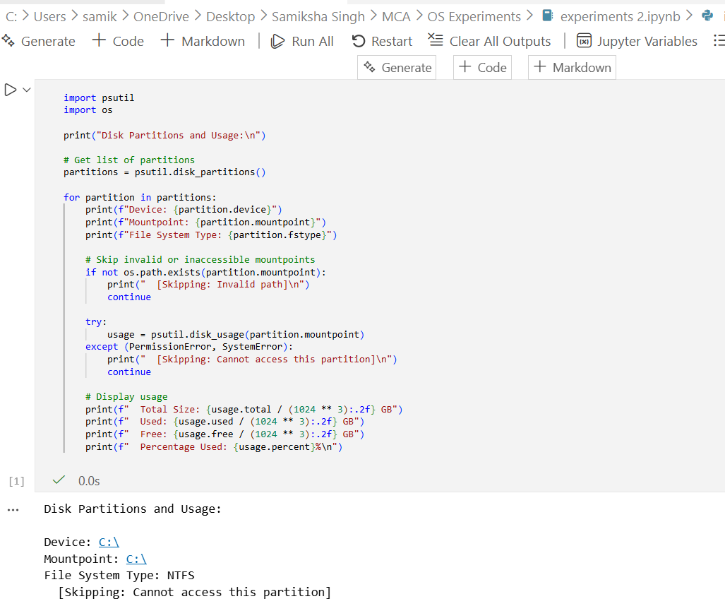
Experiment – 3

Aim: Write a Python program to display total memory, used memory, and available memory using the psutil library.
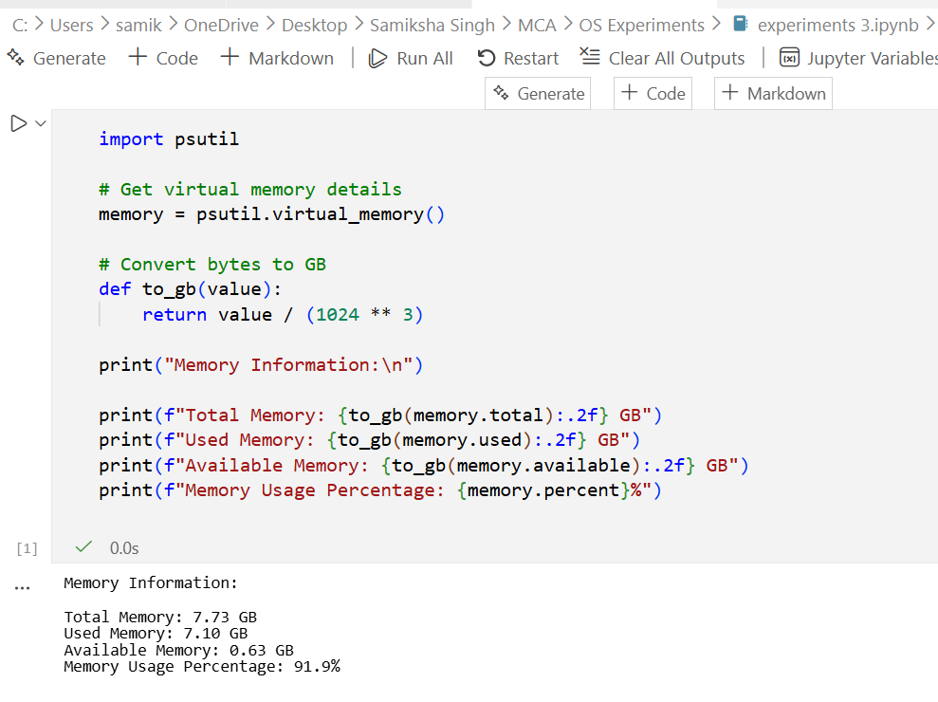
Experiment – 4

Aim: Write a Python program to list the top 5 running processes (process name + PID).
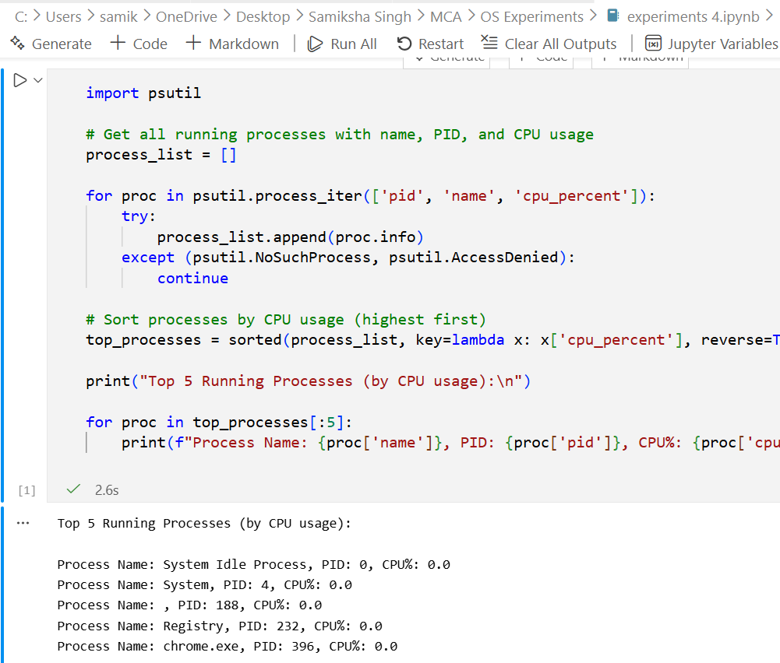
Experiment – 5

Aim: Write a Python program to display Monitor Network Statistics (Bytes Sent/Received).
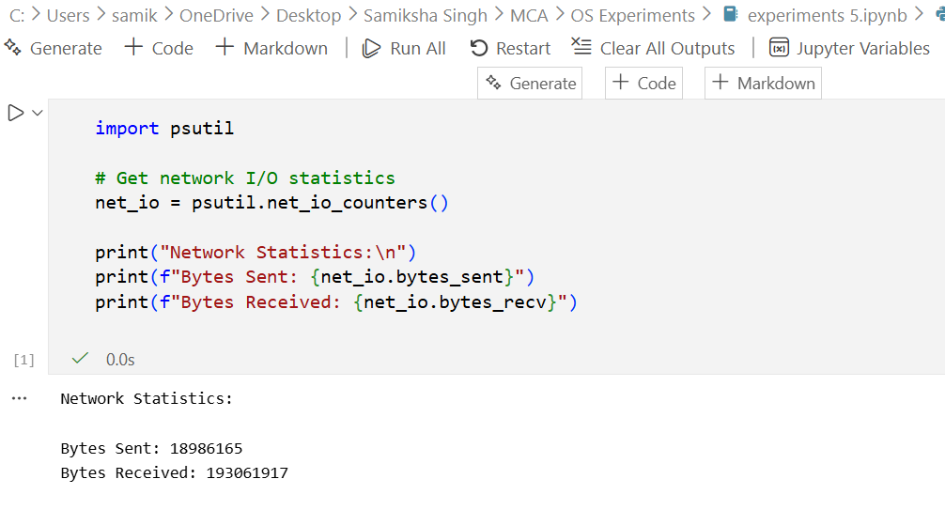

Experiment – 6

Aim: Implement First Come First Serve (FCFS) CPU scheduling in Python.
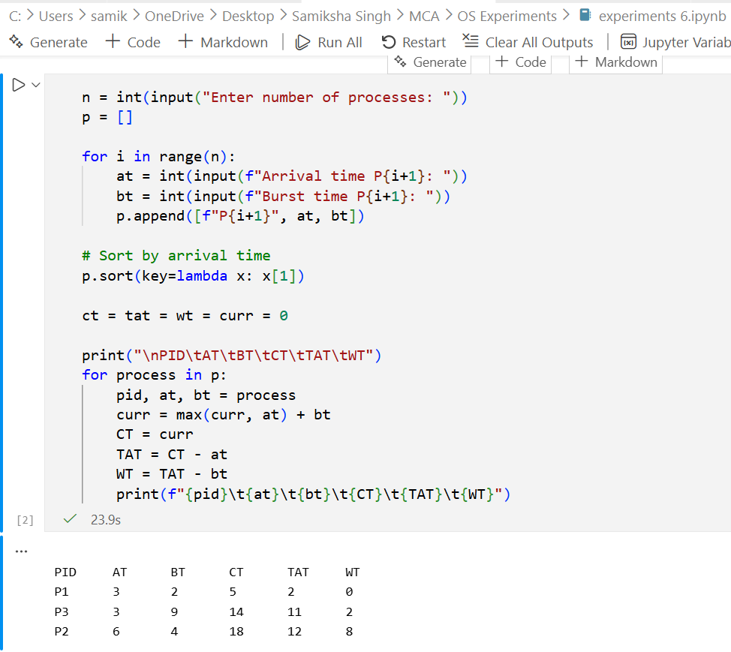
Experiment – 7

Aim: Implement Round Robin Scheduling with different time quantum.
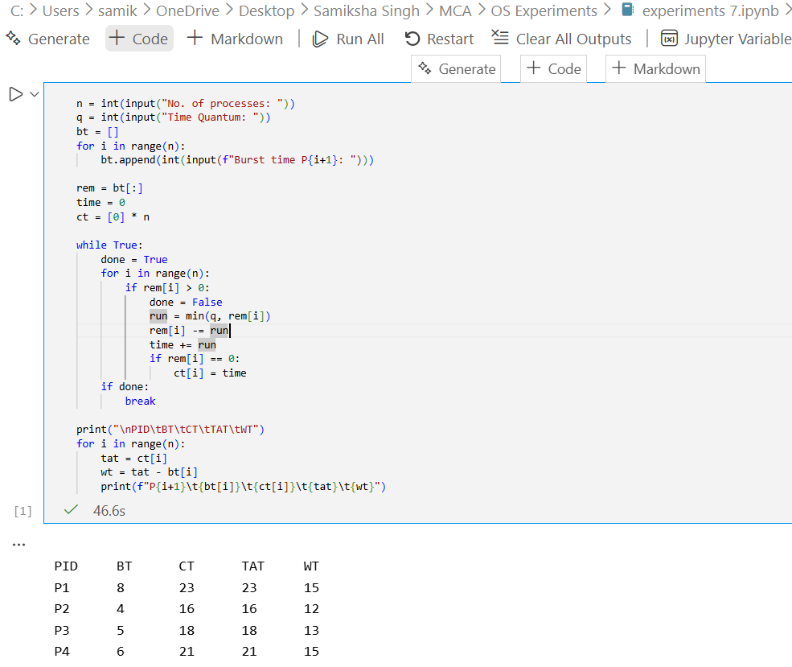
Experiment – 8

Aim: Implement Priority Scheduling and show waiting time vs turnaround time.
